Helpful Information for First Responders
Please remember TALK Tactics:
Take it slow
Ask simple questions
Limit reality checks
Keep eye contact

When assisting persons with Dementia

La Crosse Mobile Crisis 784-4357 (HELP)

My Name: __________ Date of Birth: / /

I prefer to be called _________________________________

I CANNOT BE LEFT ALONE

My Primary Care Partner is:
Name Phone # Relationship

Alternate Emergency Contacts (Name, Address, Best Contact #, Relationship)
1.__________________________________________________________________________________________________________________________________________________________________________________2.__________________________________________________________________________________________________________________________________________________________________________________

Sensory Aides Needed: Hearing Aids Glasses Walker Cane Other:

Things that upset me and how I show distress:

I may be calmed by:

Anything else I want you to know to best help me during a crisis:

Medical Conditions:
Allergies:
Pain Areas: Preferred Hospital: *Please attach medication list

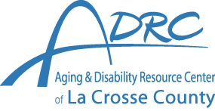

24 HOUR PLAN IF CAREGIVER IS UNAVAILABLE
Main: 608-785-5700
24 Hour CRISIS: 608-784-4357 (HELP)

