National Pizza Week

SUNDAY, JANUARY 12, 2025

MONDAY, JANUARY 13, 2025
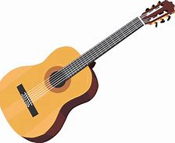
9:45am Exercise with Emily – 1000 Day Room

10:30am Bible Study with Frank Corona – Chapel

2:00pm Guitar Music with Frank Moore – Dining Room

3:30pm Room Visits with Grace

5:45pm Evening Lounge Program w/ Grace – 800 Day Room

TUESDAY, JANUARY 14, 2025

9:45am Exercise with Kathy – 1000 Day Room

10:15am Winter Craft with Kathy – 1000 Day Room

1:45pm Protestant Church Service & Communion – Dining Room

- With English Lutheran Church

2:00pm Room Visits with Kathy

3:30pm Creative Stimulation Visits w/ Grace

5:45pm Jeopardy with Grace – 800 Day Room


WEDNESDAY, JANUARY 15, 2025

9:30am Pet Visits with Lily, Hector, & Shep

10:00am Dice Game with Lori – 1000 Day Room

1:30pm Manicures in the 800 Day Room

3:00pm Pet Visits with Argos

5:45pm Evening Lounge Program w/ Grace – 800 Day Room


THURSDAY, JANUARY 16, 2025

9:45am Exercise with Kathy - 1000 Day Room

10:15am UNO Card Game with Lori – 1000 Day Room

11:30am Domino’s Pizza Order in (for those signed up) – Recreation Room

2:00pm Word Service w/ Catholic Communion – Chapel
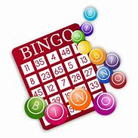
Rosary to follow

FRIDAY, JANUARY 17, 2025

10:00am Trivia Tournament to Rooms
Weekly calendars delivered

2:00pm Bingo – Dining Room

Sign-ups start Tuesday, December 24th
at 10:30am on clipboards outside Recreation Room
(no early sign-ups taken)

January 16th – Domino’s Pizza Order - $$$
January 31st – Fried Egg Breakfast - Free

SATURDAY, JANUARY 18, 2025

Menu Week 5

