National Candy Month

SUNDAY, JANUARY 19, 2025


MONDAY, JANUARY 20, 2025 “Martin Luther King Jr Day”

9:45am Exercise with Ashlie – 1000 Day Room

10:15am Room Visits with Ashlie

2:00pm Dice Game with Ashlie – Recreation Room

3:30pm Room Visits with Ashlie

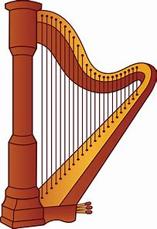
TUESDAY, JANUARY 21, 2025

9:45am Exercise – 1000 Day Room

10:30am Harp Music w/ Shari Sarazin – 1000 Day Room

1:45pm Protestant Church Service – Dining Room
- With Frank Corona

3:30pm Room Visits with Rec Staff


WEDNESDAY, JANUARY 22, 2025

9:30am Pet Visits with Lily, Hector, & Shep

10:00am Snowman Roll & Cover Dice Game – 1000 Day Room

1:15pm Intergenerational Group w/ State Rd 3rd Graders - Dining Room

3:00pm Pet Visits with Argos


THURSDAY, JANUARY 23, 2025

9:30am Bookcart Visits with LaVerne

9:45am Exercise - 1000 Day Room

10:15am Winter Crafts – 1000 Day Room

2:00pm Word Service w/ Catholic Communion – Chapel
Rosary to follow

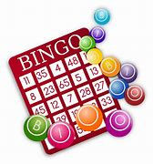
3:30pm Room Visits with Ashlie

FRIDAY, JANUARY 24, 2025

10:00am Trivia Tournament to Rooms
Weekly calendars delivered

2:00pm Bingo – Dining Room

SATURDAY, JANUARY 25, 2025

Sign-ups start Tuesday, December 24th
at 10:30am on clipboards outside Recreation Room
(no early sign-ups taken)

TBD - Domino’s Pizza Order - $$$
January 31st – Fried Egg Breakfast - Free
Menu Week 1

