


National Grilling Month

SUNDAY, JULY 27, 2025

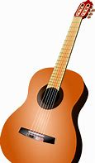

MONDAY, JULY 28, 2025

9:45am Exercise with Tom - 1000 Day Room

10:30am Bible Study with Frank Corona – 800 Day Room

2:00pm Guitar Music with Frank Moore – 800 Day Room (Terri)

TUESDAY, JULY 29, 2025


9:30am Pet Visits with Lily & Shep

9:45am Exercise with Emily – 1000 Day Room

10:15am Reminiscing with LaVerne & Angie – 1000 Day Room

1:45pm Protestant Church Service – 800 Day Room
w/ English Lutheran Church


3:30pm Room Visits w/ Emily

WEDNESDAY, JULY 30, 2025

10:00am Round the Clock Dice Game w/ Tom – 1000 Day Room

1:30pm Manicures – 1000 Day Room

3:00pm Pet Visits with Argos

THURSDAY, JULY 31, 2025

9:45am Exercise with Tom - 1000 Day Room

10:15am UNO Card Game with LaVerne & Angie – 1000 Day Room

2:00pm Word Service w/ Catholic Communion – 800 Day Room

3:30pm Room Visits w/ Emily

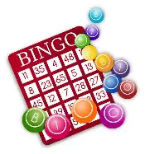
FRIDAY, AUGUST 1, 2025

10:00am Trivia Tournament to Rooms
Weekly activity calendars delivered

2:00pm Bingo – 1000 Day Room

SATURDAY, AUGUST 2, 2025

Menu Week 3

Sign-ups start Tuesday, July 29th
at 10:30am on clipboards outside Recreation Room
(no early sign-ups taken)

August 7th – Pontoon Boat Ride – Free

