Happy Halloween
SUNDAY, OCTOBER 27, 2024
Bring your carved/decorated pumpkins to the Hillview Main Dining Room between Monday, Oct 28th – Tuesday Oct 29th for the contest! Don’t forget to place your name on it.


12:00pm Green Bay Packers vs Jacksonville Jaguars - FOX

MONDAY, OCTOBER 28, 2024

9:45am Exercise with Lori – 1000 Day Room

10:30am Bible Study with Frank Corona – Chapel

2:00pm Guitar Music with Jay Hoffman – Dining Room

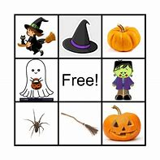
TUESDAY, OCTOBER 29, 2024

9:45am Exercise with Steph – 1000 Day Room

10:15am Halloween JINGO – 1000 Day Room

1:45pm Protestant Church Service – Dining Room
- With English Lutheran Church

3:30pm Creative Stimulation Visits (for those targeted)

WEDNESDAY, OCTOBER 30, 2024
Voting for pumpkin decorating/carving contest Today & Thursday in Main Dining Room!

9:30am Pet Visits with Shep & Hector


10:30am -1:00pm Brat Sale in the Recreation Room
Proceeds go towards Entertainment at Hillview Terrace

1:15pm Intergenerational Group – Dining Room
w/ State Road 3rd Graders dressed in Halloween Costumes

3:00pm Pet Visits with Argos

3:30pm Lounge Program (for those targeted) w/ Grace – 800 Day Room

5:45pm Evening Lounge Program w/ Sadie – 800 Day Room

THURSDAY, OCTOBER 31, 2024 “Halloween”

Sign-ups start Tuesday, Sept 24th
at 10:30am on clipboards outside Recreation Room
(no early sign-ups taken)

November 6th – Walmart Outing - $$$
November 15th – Waffle Breakfast – Free
November 19th – Culver’s Order in - $$$

9:45am Exercise with Emily – 1000 Day Room

10:15am Coloring Group with LaVerne & Angie
– 1000 Day Room

2:00pm Word Service w/ Catholic Communion – Chapel
Rosary to follow

FRIDAY, NOVEMBER 1, 2024
Winners of the Pumpkin Decorating/Carving Contest will be announced!
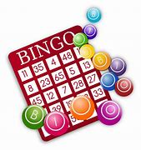
10:00am Trivia Tournament Room to Room
Weekly calendars delivered to rooms

2:00pm Bingo – Dining Room

SATURDAY, NOVEMBER 2, 2024

3:00pm 654 Dice Game w/ Allison – 1000 Day Room
Menu Week 4

